APPLICATION FORM: Bainbridge Island Studio Tour’s

DEADLINE: March 31, 2024

**Name:** Click here to enter text.

**Address:** Click here to enter text.

**Phone:** Click here to enter text. **E-mail:** Click here to enter text.

**Graduation year:** Click here to enter text.

**School:** Click here to enter text. **Current grade (junior or senior):** Click here to enter text.

**Artistic medium(s):** Click here to enter text.

**I hereby certify that the information is correct, and the work in the photos was created completely by me.**

**[Typing in your name here serves as your electronic signature] Signed:** Click here to enter text.

Submit this form with five photos of your artwork (different pieces are preferred, and a variety of art mediums are fine). Submit a 1-page artist’s statement **or** the attached artist’s statement form. All applications must be received electronically by midnight on **March 31, 2024.** This award is open to all Bainbridge Island, Washington, students and residents that are a Junior or Senior in High School (attending BHS or EHHS) as of March 2024. The cash prizes are awarded for outstanding work in the visual arts, as determined by select members of the Bainbridge Island Studio Tour Board. The winners will be announced at the BHS Spring Arts Festival awards ceremony on May 18, 2024. On behalf of the artists from the 2023 BI Studio Tour, we thank you for applying, and good luck!

Specs: Name your files with your full name, then subject, and year.

Ex: Laura Jones app 2024, Laura Jones statement 2024, Laura Jones photo 1 2024

Photo requirements: Send five photos, jpegs, each sized to 72 dpi, 1920 pixels on the longest side.

(Your photos should be of 5 different works of art. For 3-D pieces you can use two of your 5 photos

to show different angles – but please only submit 5 photos in total)

Submit everything at the same time.

E-mail app, statement, and photos to: **bistboard@gmail.com**

Checklist:

* Application form (as a PDF or Word doc only)
* Artist’s statement
* 5 photos

Info: Dinah Satterwhite, 206-842-0504, bistboard@gmail.com

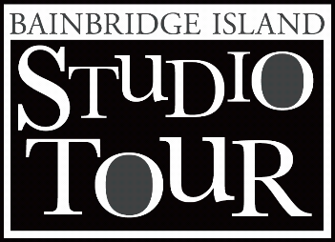Funding: The Youth Art Award is funded solely from optional donations

received in the prior calendar year from BI Studio Tour artists.

Bainbridge Island Studio Tour’s



Artist’s Statement

(Complete this form, OR use your own artist’s statement)

**Name:** Click here to enter text.

**Artistic Medium(s):** Click here to enter text.

**Tell us about your art, and what you are trying to say:**

Click here to enter text.

**How / why did you choose this medium?**

Click here to enter text.

**Are there any special techniques or tools that you use, and/or what makes your work different?**

Click here to enter text.

**What inspires you?**

Click here to enter text.

**[optional] Feel free to share a fun story about your art, about a special discovery, about a mistake, about how the viewer should approach your work, about what you enjoy most about making your art, about what creating your art does for you, etc.**

Click here to enter text.